Ex.No: 1:- Perform the following, for the following experiments:

(i)Do the Requirement Analysis and Prepare SRS

OBJECTIVE: To implement Requirement Analysis and Prepare SRS.

DESCRIPTION:

- The customer requires complete requirements are described in a formal document called software requirements specification (SRS).

- Software requirements specification (SRS) document is formal document that provides the complete description of proposed software, i.e., what the software will do without describing how it will do so.

PROGRAM:

SRS is needed for a variety of reasons:

- Customer and user rely more on and better understand a written formal document than some technical specification .It provides basis for later stages of software development.It acts as the reference document for the validation and verification of the work products and final software.

- It is treated as an agreement on the features incorporated in the final system of project between the customer and the supplier.A good quality SRS ensures high-quality software product.A high-quality SRS reduces development effort.

Characteristics of the SRS:

A good SRS should possess the following desirable Characteristics.

- Correctness, Unambiguity, Completeness, Consistency, Should be ranked for importance and/or stability, Verifiability, Modifiability, Testability, Validity, Traceability

Components of an SRS:

Requirements document deals with following components

- Functional requirements

- Performance requirements

- Design constraints(hardware, Software)

- External interface requirements.

Structure of an SRS(IEEE):

- Introduction
Purpose Scope
Definition, acronyms, and abbreviations References
Document overview

- General description

Product perspective

Product functions

User characteristics

General constraints

Assumptions and dependencies

- Specific requirements

Functional Requirements

External interface requirements

Performance requirements

Design constraints

Security requirements

Maintainability requirements

Reliability requirements

Availability requirements

Database requirements

Document requirements

Safety requirements

- Requirements Specification Methods:

- Decision Tree and Decision Table

- Program Design Languages(PDL)

- Regular Expressions

- Graphical Methods

- Mathematical Methods

- Requirements Validation:

- Requirements validation is an iterative process in the requirements development process that ensures that customer requirements are accurately and clearly specified in the SRS document

Requirements Validation Methods:

- Requirements Review

- Requirements Inspection

- Test Case Generation

- Reading

- Ambiguity, understand ability, completeness, redundancy, Testability, Modifiability,

Traceability.

- Prototyping

VIVA QUESTIONS:

- What is SRS?
Ans: SRS means Software Requirement Analysis.
- What is the use of SRS?
Ans: Inorder to develop a software we need SRS document.

ii) Draw E-R diagrams, DFD, CFD and structured charts for the project.

(1)Course Registration System

(2)Students Marks Analyzing System

(3)Online Ticket Analyzing System

(4)Stock Maintenance

(1).COURSE REGISTRATION SYSTEM :-

ER DIAGRAMS:-

An Entity Relationship (ER) Diagram is a type of flowchart that illustrates how “entities” such as people, objects or concepts relate to each other within a system. ... ER diagrams also are often used in conjunction with data flow diagrams (DFDs), which map out the flow of information for processes or systems.
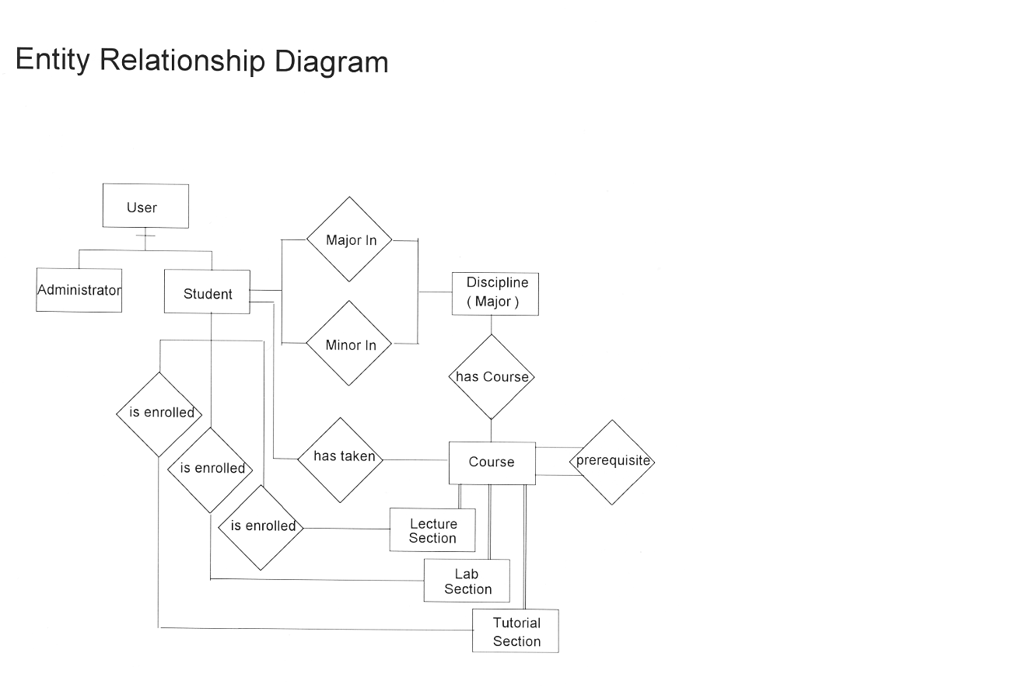

DATA FLOW DIAGRAM:-

Data flow diagram is often used as a preliminary step to create an overview of the Course without going into great detail, which can later be elaborated. it normally consists of overall application dataflow and processes of the Course process. It contains all of the user flow and their entities such all the flow of Course, Fees, Syllabus, Students, Trainers, Registration, and Login. All of the below diagrams has been used for the visualization of data processing and structured design of the Course process and working flow.
Zero Level Data Flow Diagram(0 Level DFD) Of Course Registration System :

This is the Zero Level DFD of Course Registration System, where we have elaborated the high level process of Course. It’s a basic overview of the whole Course Registration System or process being analyzed or modeled. It’s designed to be an at-a-glance view of Trainers, Registration and Login showing the system as a single high-level process, with its relationship to external entities of Course, Fees and Syllabus. It should be easily understood by a wide audience, including Course, Syllabus and Trainers In zero leve DFD of Course Registration System, we have described the high level flow of the Course system.
High Level Entities and proccess flow of Course Registration System:

- Managing all the Course
- Managing all the Fees
- Managing all the Syllabus
- Managing all the Students
- Managing all the Trainers
- Managing all the Registration
- Managing all the Login
First Level Data Flow Diagram(1st Level DFD) Of Course Registration System:

First Level DFD (1st Level) of Course Registration System shows how the system is divided into sub-systems (processes), each of which deals with one or more of the data flows to or from an external agent, and which together provide all of the functionality of the Course Registration System system as a whole. It also identifies internal data stores of Login, Registration, Trainers, Students, Syllabus that must be present in order for the Course system to do its job, and shows the flow of data between the various parts of Course, Syllabus, Registration, Login, Trainers of the system. DFD Level 1 provides a more detailed breakout of pieces of the 1st level DFD. You will highlight the main functionalities of Course.

Main entities and output of First Level DFD (1st Level DFD):

- Processing Course records and generate report of all Course
- Processing Fees records and generate report of all Fees
- Processing Syllabus records and generate report of all Syllabus
- Processing Students records and generate report of all Students
- Processing Trainers records and generate report of all Trainers
- Processing Registration records and generate report of all Registration
- Processing Login records and generate report of all Login

Second Level Data Flow Diagram(2nd Level DFD) Of Course Registration System :

DFD Level 2 then goes one step deeper into parts of Level 1 of Course. It may require more functionalities of Course to reach the necessary level of detail about the Course functioning. First Level DFD (1st Level) of Course Registration System shows how the system is divided into sub-systems (processes). The 2nd Level DFD contains more details of Login, Registration, Trainers, Students, Syllabus, Fees, Course.

Low level functionalities of Course Registration System:-

- Admin logins to the system and manage all the functionalities of Course Registration System.
- Admin can add, edit, delete and view the records of Course, Syllabus, Trainers, Login.
- Admin can manage all the details of Fees, Students, Registration.
- Admin can also generate reports of Course, Fees, Syllabus, Students, Trainers, Registration.
- Admin can search the details of Fees, Trainers, Registration.
- Admin can apply different level of filters on report of Course, Students, Trainers.
- Admin can tracks the detailed information of Fees, Syllabus, Students, , Trainers.

(2)Students Marks Analyzing System:-

ER Diagram:-
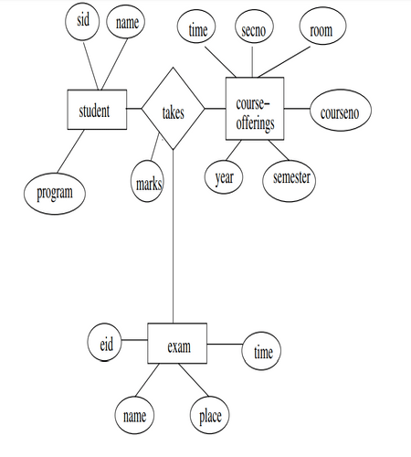

0 Level DFD Students Marks Analyzing System:-

The 0 level dfd known as context level data flow diagram. The context level data flow diagram (dfd) is describe the whole system. The (o) level dfd describe the all user modules who run the system. Below context level data flow diagram of Student management system project shows the one Admin user can operate the system. Admin do all activities after login to system.
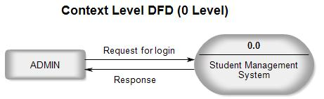

1st level DFD – Students Marks Analyzing System:-

The Admin side DFD describe the functionality of Admin. Admin is a responsible person who run the project. After login to system admin can first Add Course Detail and Teacher Detail and then add student detail by course wise. and admin can manage student reports and fees payment detail.

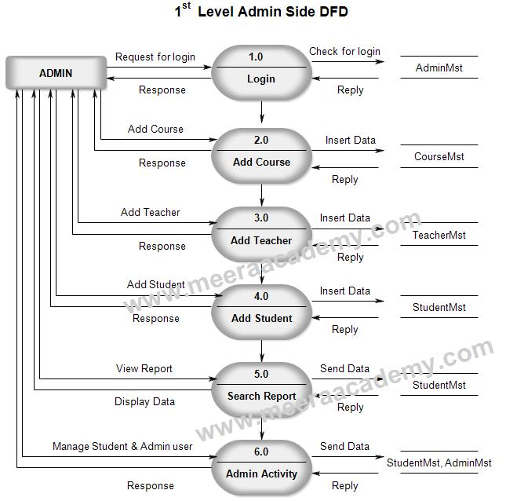

2nd Level DFD – Level 4.0
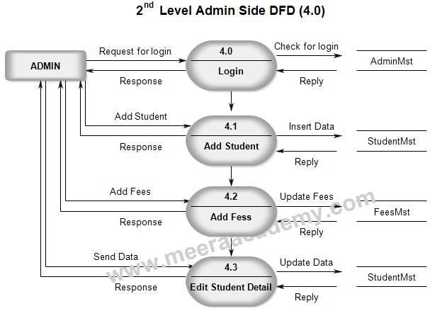

(3)Online Ticket Analyzing System:-

ER DIAGRAM:-
This ER (Entity Relationship) Diagram represents the model of Ticket Reservation System Entity. The entity-relationship diagram of Ticket Reservation System shows all the visual instrument of database tables and the relations between Seats Availability, Stations, Trains,
Ticket Reservation System entities and their attributes :
Trains Entity: Attributes of Trains are train_id, train name, train number, train_seat_number, train ticket, train type, train description
Seats Availability Entity: Attributes of Seats Availability are seat_id, seat_train_id, seat_customer_id, seat number, seat type, seat description
Fare Entity: Attributes of Fare are fare_id, fare_ticket_id, fare title, fare type, fare description
Stations Entity: Attributes of Stations are station_id, station_name, station_type, station_description
Booking Entity: Attributes of Booking are booking_id, booking_ticket_id, booking_title, booking type, booking date, booking description.
Passengers Entity : Attributes of Passengers are passenger_id, passenger_name, passenger_mobile, passenger_email, passenger_username, passenger password, passenger_address and Passengers etc. It used structure data and to define the relationships between structured data groups of Ticket Reservation System functionalities. The main entities of the Ticket Reservation System are Trains, Seats Availability, Fare, Stations, Booking and Passengers.
Description of Ticket Reservation System Database:
The details of Trains is store into the Trains tables respective with all tables
Each entity (Passengers, Fare, Booking, Seats Availability, Trains) contains primary key and unique keys.
The entity Fare, Booking has binded with Trains, Seats Availability entities with foreign key.
There are one-to-one and one-to-many relationships available between Booking, Stations, Passengers, and Trains.
All the entities Trains, Booking, Fare, Passengers are normalized and reduce duplicacy of records.
We have implemented indexing on each tables of Ticket Reservation System tables for fast query execution
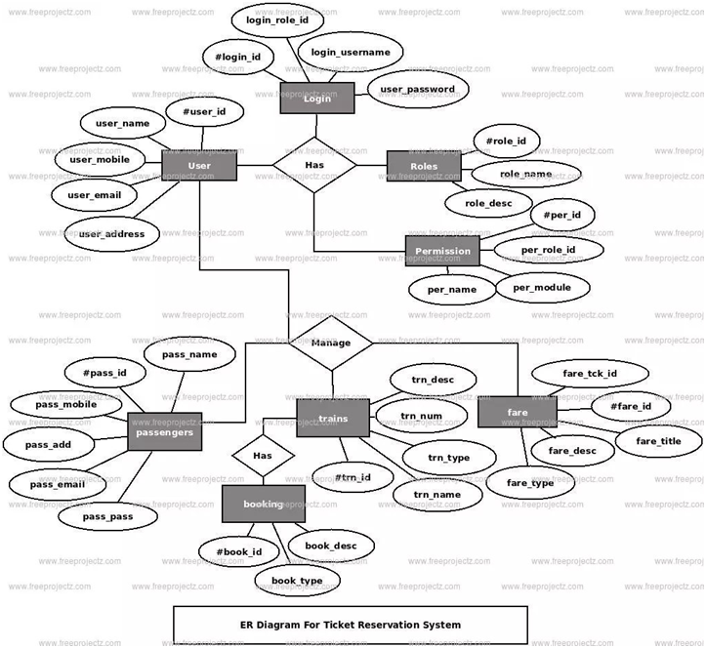
Data flow Diagram:-
Ticket Reservation System Data flow diagram is often used as a preliminary step to create an overview of the Ticket without going into great detail, which can later be elaborated.it normally consists of overall application dataflow and processes of the Ticket process. It contains all of the userflow and their entities such all the flow of Trains, Seats, Fare, Stations, Booking, Passengers, Ticket. All of the below diagrams has been used for the visualization of data processing and structured design of the Ticket process and working flow.
Zero Level Data Flow Diagram(0 Level DFD) Of Ticket Reservation System :
This is the Zero Level DFD of Ticket Reservation System, where we have eloborated the high level process of Ticket. It’s a basic overview of the whole Ticket Reservation System or process being analyzed or modeled. It’s designed to be an at-a-glance view of Booking,Passengers and Ticket showing the system as a single high-level process, with its relationship to external entities of Trains,Seats and Fare. It should be easily understood by a wide audience, including Trains,Fare and Booking In zero leve DFD of Ticket Reservation System, we have described the high level flow of the Ticket system.
High Level Entities and proccess ow of Ticket Reservation System:
- Managing all the trains.
- Managing all the seats.
- Managing all the fare.
- Managing all the sations
- Managing all the bookings.
- Managing all the Passengers.
- Managing all the Tickets
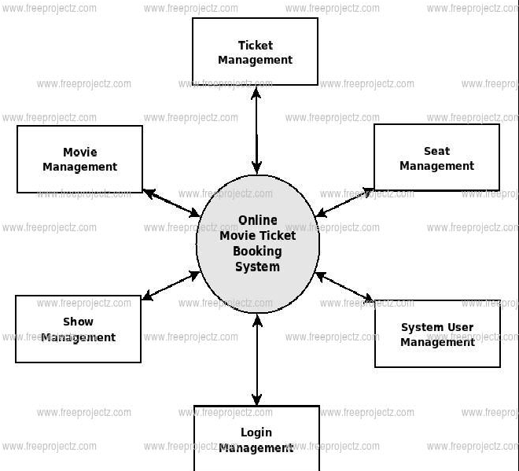

First Level DFD (1st Level) of Ticket Reservation System shows how the system is divided into sub-systems (processes), each of which deals with one or more of the data flows to or from an external agent, and which together provide all of the functionality of the Ticket Reservation System system as a whole. It also identifies internal data stores of Ticket, Passengers, Booking, Stations, Fare that must be present in order for the Ticket system to do its job, and shows the flow of data between the various parts of Trains, Fare, Passengers, Ticket, Booking of the system. DFD Level 1 provides a more detailed breakout of pieces of the 1st level DFD. You will highlight the main functionalities of Ticket.
Mainentities and output of First Level DFD:-
- Processing Train records and generates report of all the trains.
- Processing Seat records and generates report of all the seats.
- Processing Fare records and generates reports of all the fares.
- Processing Stations records and generates reports of all the stations.
- Processing Booking records and generates reports of all the Bookings.
- Processing Passengers records and generates reports of all the Passengers.
- Processing Tickets records and generates reports of all the Tickets
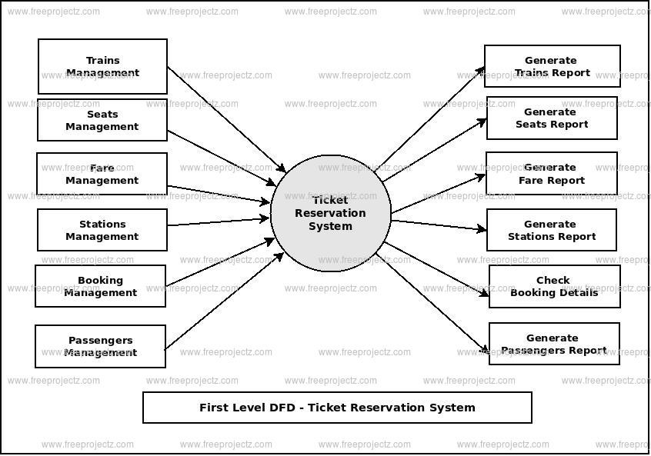

Second Level Data Flow Diagram(2nd Level DFD) Of Ticket Reservation System :
DFD Level 2 then goes one step deeper into parts of Level 1 of Ticket. It may require more functionalities of Ticket to reach the necessary level of detail about the Ticket functioning. First Level DFD (1st Level) of Ticket Reservation System shows how the system is divided into sub-systems (processes). The 2nd Level DFD contains more details of Ticket, Passengers, Booking, Stations, Fare, Seats, and Trains.
Low level functionalities of Ticket Reservation System:-
- Admin logins to the system and manage all the functionalities of Ticket Reservation System.
- Admin can add, edit, delete and view the records of Trains, Fare, Booking, Ticket.
- Admin can manage all the details of Seats, Stations, Passengers
- Admin can also generate reports of Trains, Seats, Fare, Stations, Booking, Passengers
- Admin can search the details of Seats, Booking, and Passengers.
- Admin can apply different level of filters on report of Trains, Stations, and Booking.
- Admin can tracks the detailed information of Seats, Fare, Stations, Booking

4) STOCK MAINTENANCE:-

ER-Diagram:-
This ER (Entity Relationship) Diagram represents the model of Stock Management System Entity. The entity-relationship diagram of Stock Management System shows all the visual instrument of database tables and the relations between Product, Bill, Stock, Store etc. It used structure data and to define the relationships between structured data groups of Stock Management System functionalities. The main entities of the Stock Management System are Stock, Product, Product Quality, Bill, Customer and Store.
Stock Management System entities and their attributes
- Stock Entity:-Attributes of Stock are Stock_id, Stock number, Stock type and Stock Description.
- Product Entity:-Attributes of Product are product_id, Product_customer_id.
- Product items:-Product number, Product type, Product description.
- Product Quality Entity:-Attributes of Product Quality are Product_quality_id, Product Quality name, Product_quality_type, Product_quality_description.
- Bill Entity:-Attributes of Bill are bill_id, bill_customer_id, bill number, bill type, bill, receipt bill description.

Description of Stock Management System Database :
• The details of Stock is store into the Stock tables respective with all tables
• Each entity ( Store, Product Quality, Customer, Product, Stock) contains primary key and unique keys.
• The entity Product Quality, Customer has binded with Stock, Product entities with foreign key
• There is one-to-one and one-to-many relationships available between Customer, Bill, Store, Stock
• All the entities Stock, Customer, Product Quality, Store are normalized and reduce duplicacy of records
• We have implemented indexing on each tables of Stock Management System tables for fast query execution.
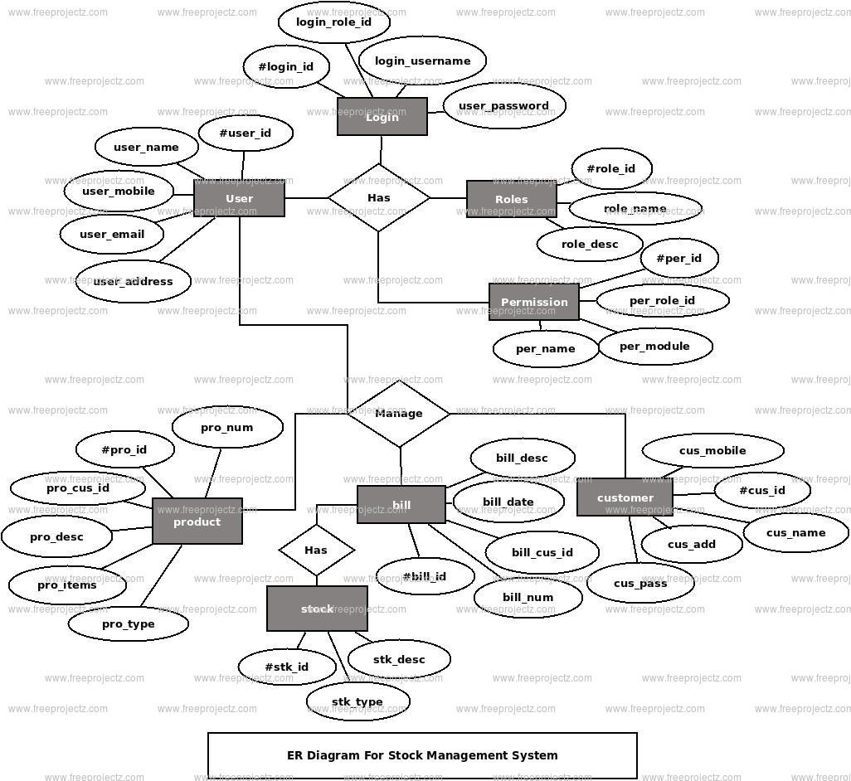

DATAFLOW DIAGRAM:-
Stock Management System Data flow diagram is often used as a preliminary step to create an overview of the Stock without going into great detail, which can later be elaborated .it normally consists of overall application dataflow and processes of the Stock process. It contains all of the user flow and their entities such all the flow of Stock, Product, Product Quality, Bill, Customer, Store, Login. All of the below diagrams has been used for the visualization of data processing and structured design of the Stock process and working flow.

• Zero Level Data Flow Diagram(0 Level DFD) Of Stock Management System:-
This is the Zero Level DFD of Stock Management System, where we have elaborated the high level process of Stock. It’s a basic overview of the whole Stock Management System or process being analyzed or modeled. It’s designed to be an at-a-glance view of Customer, Store and Login showing the system as a single high-level process, with its relationship to external entities of Stock, Product and Product Quality. It should be easily understood by a wide audience, including Stock, Product Quality and Customer In zero level DFD of Stock Management System, we have described the high level flow of the Stock system.
High Level Entities and process flow of Stock Management System:
• Managing all the Stock.
• Managing the entire Product.
• Managing all the Product Quality.
• Managing the entire Bill.
• Managing the entire Customer.
• Managing the entire Store.
• Managing the entire Login.
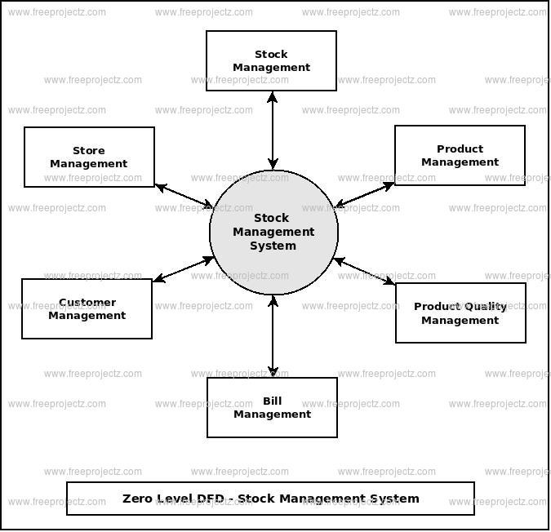
First Level DFD (1st Level) of Stock Management System:-

First Level DFD (1st Level) of Stock Management System shows how the system is divided into sub-systems (processes), each of which deals with one or more of the data flows to or from an external agent, and which together provide all of the functionality of the Stock Management System system as a whole. It also identifies internal data stores of Login, Store, Customer, Bill, Product Quality that must be present in order for the Stock system to do its job, and shows the flow of data between the various parts of Stock, Product Quality, Store, Login, Customer of the system. DFD Level 1 provides a more detailed breakout of pieces of the 1st level DFD. You will highlight the main functionalities of Stock.

First Level Data Flow Diagram(1st Level DFD) Of Stock Management System :

Main entities and output of First Level DFD (1st Level DFD):

• Processing Stock records and generates report of all Stock.
• Processing Product records and generates report of all Product.
• Processing Product Quality records and generates report of all Product Quality.
• Processing Bill records and generates report of all Bill.
• Processing Customer records and generates report of all Customer.
• Processing Store records and generates report of all Store.
• Processing Login records and generates report of all Login.

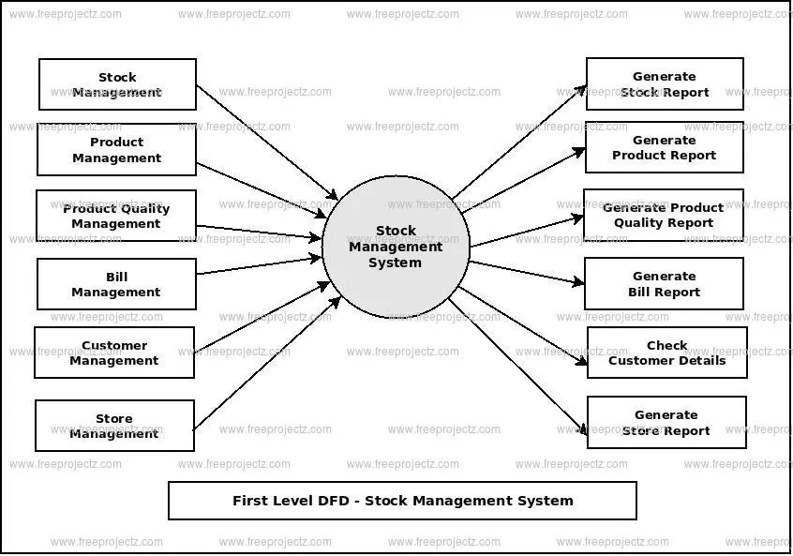
Second Level Data Flow Diagram(2nd Level DFD) Of Stock Management System :
DFD Level 2 then goes one step deeper into parts of Level 1 of Stock. It may require more functionalities of Stock to reach the necessary level of detail about the Stock functioning. First Level DFD (1st Level) of Stock Management System shows how the system is divided into sub-systems (processes).
The 2nd Level DFD contains more details of Login, Store, Customer, Bill, Product Quality, Product, andStock.
Low level functionalities of Stock Management System
- Admin logins to the system and manage all the functionalities of Stock Management System.
- Admin can add, edit, delete and view the records of Stock, Product Quality, Customer, and Login.
- Admin can manage all the details of Product, Bill, and Store.
- Admin can also generate reports of Stock, Product, Product Quality, Bill, Customer, and Store.
- Admin can search the details of Product, Customer, and Store.
- Admin can apply different level of filters on report of Stock, Bill, and Customer.
- Admin can tracks the detailed information of Product, Product Quality, Bill, Customer.

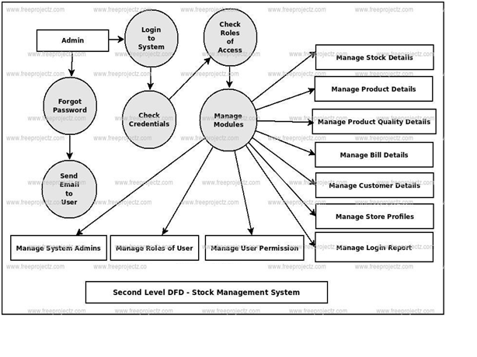

Ex.No:5
Using COCOMO model estimate effort

OBJECTIVE: To implement COCOMO model estimate effort

DESCRIPTION:

CRC method can detect a single burst of length n, since only one bit per column will be changed, a burst of length n+1 will pass undetected, if the first bit is inverted, the last bit is inverted and all other bits are correct. If the block is badly garbled by a long burst or by multiple shorter burst, the probability that any of the n columns will have the correct parity that is 0.5. so the probability of a bad block being expected when it should not be 2 power(-n). This scheme some times known as Cyclic Redundancy Code

PROGRAM:

The most fundamental calculation in the COCOMO model is the use of the Effort Equation to estimate the number of Person-Months required to develop a project. Most of the other COCOMO results, including the estimates for Requirements and Maintenance, are derived from this quantity.

Source Lines of Code
The COCOMO calculations are based on your estimates of a project's size in Source Lines of Code (SLOC). SLOC is defined such that:
- Only Source lines that are DELIVERED as part of the product are included -- test drivers and other support software is excluded
- SOURCE lines are created by the project staff -- code created by applications generators is excluded
- One SLOC is one logical line of code
- Declarations are counted as SLOC
- Comments are not counted as SLOC
The original COCOMO 81 model was defined in terms of Delivered Source Instructions, which are very similar to SLOC. The major difference between DSI and SLOC is that a single Source Line of Code may be several physical lines. For example, an "if-then-else" statement would be counted as one SLOC, but might be counted as several DSI.

The Scale Drivers
In the COCOMO II model, some of the most important factors contributing to a project's duration and cost are the Scale Drivers. You set each Scale Driver to describe your project; these Scale Drivers determine the exponent used in the Effort Equation.
The 5 Scale Drivers are:
- Precedentedness
- Development Flexibility
- Architecture / Risk Resolution
- Team Cohesion
- Process Maturity
The first two Scale Drivers, Precedentedness and Development Flexibility actually describe much the same influences that the original Development Mode did.

Cost Drivers
COCOMO II has 17 cost drivers -- you assess your project, development environment, and team to set each cost driver. The cost drivers are multiplicative factors that determine the effort required to complete your software project. For example, if your project will develop software that controls an airplane's flight, you would set the Required Software Reliability (RELY) cost driver to Very High. That rating corresponds to an effort multiplier of 1.26, meaning that your project will require 26% more effort than a typical software project.
COCOMO II defines each of the cost drivers, and the Effort Multiplier associated with each rating. Check the SystemStar help for details about the definitions and how to set the cost drivers.

COCOMO II Effort Equation:-
The COCOMO II model makes its estimates of required effort (measured in Person-Months -- PM) based primarily on your estimate of the software project's size (as measured in thousands of SLOC, KSLOC)):
Effort = 2.94 * EAF * (KSLOC)^{E}
Where
EAF Is the Effort Adjustment Factor derived from the Cost Drivers
E Is an exponent derived from the five Scale Drivers
As an example, a project with all Nominal Cost Drivers and Scale Drivers would have an EAF of 1.00 and exponent, E, of 1.0997. Assuming that the project is projected to consist of 8,000 source lines of code, COCOMO II estimates that 28.9 Person-Months of effort is required to complete it:
Effort = 2.94 * (1.0) * (8)^{1.0997} = 28.9 Person-Months

Effort Adjustment Factor
The Effort Adjustment Factor in the effort equation is simply the product of the effort multipliers corresponding to each of the cost drivers for your project.
For example, if your project is rated Very High for Complexity (effort multiplier of 1.34), and Low for Language & Tools Experience (effort multiplier of 1.09), and all of the other cost drivers are rated to be Nominal (effort multiplier of 1.00), the EAF is the product of 1.34 and 1.09.
Effort Adjustment Factor = EAF = 1.34 * 1.09 = 1.46
Effort = 2.94 * (1.46) * (8)^{1.0997} = 42.3 Person-Months
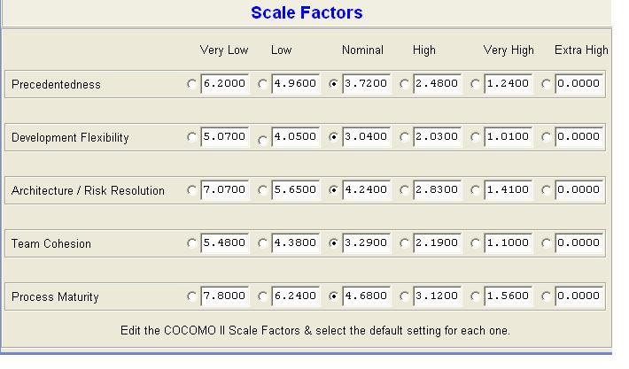

Cost Drivers
ACAP | Analyst Capability
APEX AEXP | Applications Experience
PCAP | Programmer Capability
LEXP | Programming Language Experience
VEXP | Virtual Machine Experience
PERS | Personnel Capability
PREX | Personnel Experience
PCON | Personnel Continuity
PLEX PEXP | Platform Experience
LTEX | Language and Tool Experience
 | Product Factors
RELY | Required Software Reliability
DATA | Database Size
CPLX | Software Product Complexity
RUSE | Required Reusability
DOCU | Documentation Match to Life-Cycle Needs
RCPX | Product Reliability and Complexity
 | Platform Factors
TIME | Execution Time Constraint
STOR | Main Storage Constraint
TURN | Computer Turnaround Time
VIRT | Virtual Machine Volatility
VMVH | Virtual Machine Volatility: Host
VMVT | Virtual Machine Volatility: Target
PVOL | Platform Volatility
PDIF | Platform Difficulty
PLAT | Platform
 | Project Factors
TOOL | Use of Software Tools
MODP | Modern Programming Practices
SCED | Required Development Schedule
SECU | Classified Security Application
SITE | Multisite Development
FCIL | Facilities
RVOL | Requirements Volatility

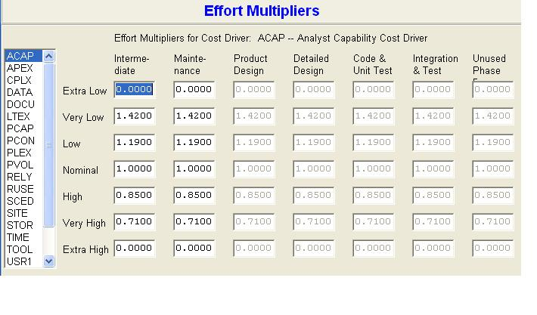
Example:

Suppose a library management system (LMS) is to be designed for an academic institution. From the project proposal, the following five major components are identified:

The database size and application experience are very important in this project. The use of the software tool and the main storage is highly considerable. The virtual machine experience and its volatility can be kept low. All other cost drivers have nominal requirements. Use the COCOMO model to estimate the development effort and the development time.

Solution:

The LMS project can be considered an organic category project. The total size of the modules is 7 KLOC. The development effort and development time can be calculated as follows: Development effort

Initial effort(E_{i}) = a * (KLOC) ^{b} a = 3.2 b = 1.05

- 3.2 * (7) ^{1.05}

- 24.6889 PM

Effort Adjustment Factors (EAF) = EAF * EAF * EAF * EAF * EAF * EAF
- 1.16*0.82*0.91*1.06*1.10*0.87
= 0.8780
Total Effort (E) = (E_{i}) * EAF

- 24.6889 * 0.8780

- 21.6785 PM

The estimated effort (E) is 21.6785 PM.The total size is 7 KLOC , which is between 2 KLOC and 32 KLOC. Thus the actual percentage of effort can be calculated as follows:

Plan and requirement (%) = 6+(6-6)/(32-2)*7 =6%

Effort = 0.06*21.6785 PM

= 1.30071 PM

System Design = 16+(16-16)/(32-2)*7

= 16%

Effort = 0.16*21.6785 PM

= 3.46856 PM

Detailed Design = 24+(26-24)/(32-2)*7

= 25%

Effort = 0.25*21.6785 PM

= 5.419625 PM

Code and Unit test = 38+(42-38)/(32-2)*7 = 39%

Effort = 0.39*21.6785 PM

= 8.454615 PM Integration and test = 22+(16-22)/(32-2)*7

= 24%

Effort = 0.24*21.6785 PM

= 5.20284 PM

The basic, intermediate, and detailed COCOMO models are in the category of COCOMO I and these are collectively known as COCOMO 81. The COCOMO I models were developed to estimate the effort, schedule, and cost of a software project.

COCOMO II

COCOMO II model was proposed to overcome the limitations of COCOMO 81 it consists of sub models, each one providing unique features for project planning and design process. The sub models are given by with effort:

- Application Composition Model

- Early Design Model

- Post-Architecture Model

- Reuse Model

- Analytical Estimation

VIVA QUESTIONS:

1.What is COCOMO?
Ans: COCOMO (Constructive Cost Model) is an algorithmic cost estimation technique proposed by Boehm, which works in a bottom-up manner.
2.What is the use of COCOMO Model?
Ans:The COCOMO model uses a multivariable size estimation model for effort estimation.
3.On what variables COCOCMO model depends?
Ans:A multivariable model depends on several variables, such as development environment, user environment, memory constraints, technique used etc.

Ex.No:6
Calculate effort using FP oriented estimation model

OBJECTIVE: To Calculate effort using FP oriented estimation model

DESCRIPTION:
To overcome the limitations of the LOC-based measurement , Alan Albrecht proposed another size estimation technique called Function Point (FP) analysis.In the FP analysis, the size of the project is estimated on the basis of functions or services requested by the customer in the requirement specification.It is a structure technique that decomposes system down into smaller components so that they can be better understood and analysed. The actual number of function points can be verified at the end of each stage of project.

PROGRAM:

FP measurement is programming language independent and programmer independent . with the help of FP more accurate estimations are possible in the early stages of software development. An important aspect of FP is the consideration of users view through requirement specification or problem description along with developers view during requirement decomposition for the FP analysis.

FP-based estimations are based on the following five information domain values and their complexities in a particular project.

- Number of inputs

- Number of outputs

- Number of inquiries

- Number of internal logical files
5. Number of external interfaces.

The value of each of these five information domains is collected and a subjective evaluation is performed to categorize them simple, average, and complex. There are certain weights assigned at each complexity level to the information domain as shown below table:

Information domain | Weights
 | Simple | average | Complex
Number of inputs | 3 | 4 | 6
Number of outputs | 4 | 5 | 7
Number of inquiries | 3 | 4 | 6
Number of internal logical files | 7 | 10 | 15
Number of external interfaces | 5 | 7 | 10
Table: Information domains and their weights.

FP estimation is performed in the following three steps:

- Calculate the unadjusted function point(UFP):

- Compute the complexity adjustment attributes(CAA):

- Compute FP

Calculate the unadjusted function point (UFP):

It is calculated by simply counting the value of each information domain and multiplying it by an appropriate weight at its complexity level. For example, the average size output of two screen layouts has the UFP value 10.

Compute the complexity adjustment attributes (CAA):

The CAAs are complexity attributes that can vary from project to project . they are computed using the following relationship.

CAA = [ 0.65 + 0.01 * ∑ CAA_{i} ]

Where CAA is complexity adjustment factor.

The CAA values are based on the importance of 14 complexity adjustment factors. These complexity adjustment factors are given by

- Data communications requirements; Need for distributed processing Need for backup and recovery

- Performance critical

- Operational environment load

- Online data entry

- Parallel input transaction

- Online update

- Complexity of input,output,files,or inquiries

- Complexity of internal processing

- Code reusability

- Usability and configuration management.

The values of these factors are rated on a five-point scale:

- 0 (not significant)

- 1 (Identical)

- 2 (moderate)

- 3 (average)

- 4 (significant)

- 5 (highly essential)

Compute FP:

FP = UFP * CAA.
Example:

Compute the FP value for the grade calculation of students . Assume that it is an average complexity size project . the information domain values are as folloes:

Number of inputs | = | 13
Number of outputs | = | 04
Number of inquiries | = | 02
Number of internal logical files = |  | 05
Number of external interfaces | = | 02

The total value of complexity adjustment attributes is 13.

Solution:

- Calculate of UFP for average complexity size project:

= (number of inputs) * 4 + (number of outputs) * 5 + (Number of inquiries) * 4 + (Number of internal logical files ) * 10 + (Number of external interfaces) * 7.

  - 13 * 4 + 4 * 5 + 2 * 4 + 5 * 10 + 2 * 7

  - 175

- Compute CAA, Which has the value = 13

CAA = [ 0.65 + 0.01 * ∑ CAA_{i} ]

- [ 0.65 + 0.01 * (13 *3) ]

- 0.65+0.01*39

=1.04

3. Compute FP = UFP * CAA = 175 * 1.04

Thus , the total value of FP is 182.

The function staffing size. It helpful to monitor the productivity level of a project. It is also useful in managing change of scope and in communicating the functional requirements. The FP computation is useful to find other metrics, such as project defect per FP, cost per FP, FP per hour productivity and so on.

VIVA QUESTIONS:

1. How to estimate the size of Project in FP?
Ans: In the FP analysis, the size of the project is estimated on the basis of functions or services requested by the customer in the requirement specification.
2. What is full form of CAA?
Ans: complexity adjustment attributes (CAA):
Point analysis has several benefits. It accurately estimates the project duration, and project .

